MANCHESTER AND DISTRICT WALKERS (MR50)

COMMITTEE MEETING

13th February 2025, 19.00 Foundry Project

AGENDA AND REPORTS

Agenda item | Requested by
- Welcome | ES
- Apologies | LE
- Acceptance of minutes from previous meeting. | All
- Fixing future meeting dates | ES / M
- Donation to Edale mountain rescue? | ES / MD
- Walk booking forms | MD
- Walk sign ups and Next of Kin | ES
- Incidents on walks – reminder to walk leaders to send details on incident to committee so ramblers report form can be completed within 10 days of incident | ES
- Dogs on leads – reminder to dog owners asked for by some | ES
- Funding for a social – communication with treasurer
Ongoing Actions
- Women’s walk leader training – navigation training organized for Sat 16th March in Staveley. Limited numbers, but with idea that those who attend are new to navigation and bring back to the group what they have learned through walks and socials. (Separate to this, interesting to see a few navigation-focused socials on the calendar). ES to put on calendar once date confirmed.
Then ES/MVDZ to put on a walk leader training walk. ES - Idea to also do a navigation/walk ideas social – talk about routes/maps/navigation questions at a pub/bar (quiet enough to talk) in central Manchester – ONGOING (after training)
Walk leader training open to all. ES to ask Margaret about whether we can get funding/top-up from area funding - ONGOING

- Women’s/Men’s only walks – proposals by members to lead women’s only walks to create safe spaces and for certain events e.g. international women’s day. Also idea for men’s only walks for men’s mental health awareness week/day in November.
When mentioned in EC meeting, others said this has had been done before in other groups, but ES to check with Diane Simcoe at Ramblers to be sure - ONGOING

- Young Ramblers weekend – SK and sub-committee met end of last year, started getting quotes. Date to be confirmed, but probably June/July.
Payment expected?
- Ramblers insurance – can only cover 2 activities at a walk, social or weekend e.g. walking and accommodation, or walking and travel organized, but not all three. We may be perceived as a travel/tour operator. Take note for socials and weekends. To add to weekend and socials organisers’ guidance? MP to see about wording. – ONGOING
- Review of actions from the last meeting. | All
- AOB  - Question from Natalie on Shropshire profit | ALL

Review of Actions from the last meeting:
ACTION 1 to confirm KC to respond to relevant Instagram messages.
ACTION 2 ES will ask Margaret Manning if there is any funding available for this (walk leader training for all)
ACTION 3 ES needs to check this with Ramblers / Area head (womens/mens only walks) (ongoing actions)
ACTION 4 to get an update from SK on young ramblers weekend (ongoing actions)
ACTION 5 to look into this legislation further, before we provide guidance on weekends. Closed, see Miranda’s report.
ACTION 6 MP to circulate documents. Closed, see Miranda’s report.
ACTION 7 Desi/Rob to review Mike Dent’s website suggestions
ACTION 8 20 person cap for scrambles Closed, see webmaster report
ACTION 9 ES to check what we should / can minute on confidential matters
ACTION 10 LE to post on FB about ICE cards and how to add emergency contacts on your phone
ACTION 11 ES to get update from Joanna and Ed on footpath maintenance / volunteering
ACTION 12 refresh the member stories on the website

REPORTS

Chair (Ellie)

Hello MAD walkers,
We have started the year strong with lots of well attended walks (despite snow and ice) and the calendar for walks, socials and weekends is filling up nicely – thank you to all who have contributed to that.

On Saturday 4th January we were mentioned twice on the BBC. First off, at 7:45 am I did a 5-minute interview about the group on BBC Radio Manchester (this can be heard on BBC Sounds for those who fancy listening). On the Saturday, one of our walk leaders needed some assistance from Mountain Rescue after falling and dislocating his shoulder. Edale Mountain Rescue attended the scene and Tom was taken off-site by helicopter to an ambulance. Thank you to those who stayed with Tom, kept him warm with layers and an emergency blanket, and thank you to those who continued the walk and got everyone back down safely to Edale. Following this, we were mentioned in a BBC article. However, the main focus of the article was the parked cars hampering emergency services in the Peak District and our preparedness was mentioned in the article, so that is something to be proud of.

In some ways, it has been quite a dramatic start to the year, so let’s see what the rest of 2025 brings.

Ellie

Secretary (Lottie)

Not much to report, its been a fairly quiet month for my secretary duties. In other news I’m running a weekend to the Lakes in April.

Walks Co Ordinator (Mike & Kim)

It’s been a busy couple of months for walks. Off the back of an idea which came out of our handover meeting, we created an automated email which invites walk leaders to fill in a form after their walk. The initial intention was to keep track of backmarkers and radios, but it also allows us to collect information on how many people are attending each walk and encourages leaders to share any queries or feedback they may have. This seems to have received a positive response, which is great.
In the months of December and January we had an average group size of 27, ranging from a group of 11 to an impressive 48 at the start of the year. Thanks to our amazing walk leaders (18 in total) there has been plenty of choice with 20 walks on offer, 90% of which were accessible by Public Transport. Saturday remains the most popular day with 70% of the walks, and 60% were graded as Moderate. The remaining 40% is an equal split between Leisurely and Strenuous so it’s great to see we have all bases covered. In total, we have covered 193.4 miles and 8,687 meters of ascent (according to the walk description) which in itself is a pretty impressive achievement.
A special shout out goes to Anna Caulcott who not only led her first and second walks for the group, but also stepped in to take over when another walk leader was unable to continue due to injury.
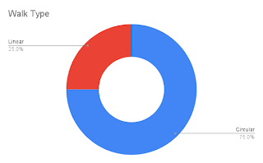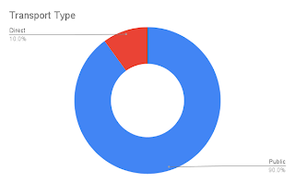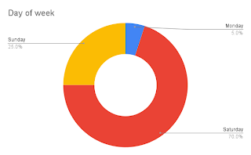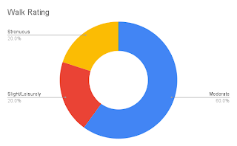
Mike Dent and Kim Jarvis - Walks Coordinators

Membership Secretary (James)
Since my last report, Ramblers granted me access to the Membership Insight Hub.
As of 13/02/2025 we have 619 members. Since 12/11/2024 there have been 39 new members and 5 are showing as having re-joined.

The are currently 362 members of the MAD Walkers Members facebook group and it is proving to be simple to verify requests from people to join once they are showing on the Ramblers membership list. This is usually the next working day after they have paid.

I am in the process of gathering together the details of those who’ve signed up for walks and indicated they’re not a member of the group, so an email can be sent using Mailchimp to attempt to convert some of these to memberships.

Treasurer (Natalie)
See below extract from the accounts updated 10/02/2025. The total currently stands as £4,635.82.
However, please be aware we have a number of outstanding payments yet to process that include: 6 month meet-up subscription, receipts for Shropshire weekend, navigation training (that will use the walk leader funding) and a deposit for an upcoming weekend proposal (in April). Delays in payments have been due to the continued difficulty we are having with transferring bank account access, and we appreciate everyone's patience and understanding as we resolve this with the bank.

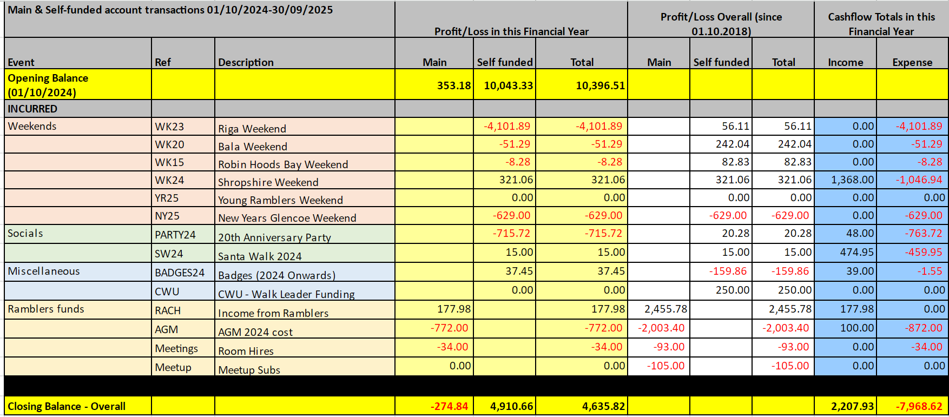
Social Secretary (Chip)

Communications And Social Media (Katie and Ed)
An observation from the last few weeks is the number of people who message specifically to ask whether it’s okay to meet a walking group at the starting point rather than at the Manchester departure station. There has already been some discussion on how to tackle this.
Instagram
From 1st December 2024 to 11th February 2025:
10 posts and 4 stories (stories have all been posted by other members, and shared by us).
27,272 views from 2,357 accounts. The majority of this is from posts rather than anything else, but this reflects the fact that we don’t currently post many stories or reels. 22.4% of our views were from non-followers which might suggest new reach.
413 interactions from 239 accounts, mostly followers but with a small number of non-followers (2.5%).
Overall growth of 110 followers, bringing the total to 2,595. The majority are in the target age range as the biggest bracket is 25-34 (46.9%). This and the 35-44 bracket (36.9%) make up the majority of followers. Under gender, overall split is 72.5% women, 27.5% men.
Facebook
For the public page, audience data is only available for the 28 days from 16th January to 12th February.
Since 11th December 2024 there have been 10 posts and 4 stories, as these always match the Instagram account.
16,137 views. As with Instagram, the majority of this is from photos as that’s what we mainly post.
The views were from 67.8% followers to 32.2% non-followers, again potentially indicating new reach.
862 interactions from 90.4% followers and 9.6% non-followers.
Overall growth of 23 followers, bringing the total to 5,557. On this platform the biggest bracket is 35-44 (45.8%). This and the 25-34 bracket (32.4%) make up the majority of followers. As has probably been stated previously, the difference will be down to popularity of platforms based on age ranges, and probably because followers on Facebook will have built up (and aged!) over a longer period. Under gender, overall split is almost exactly the same as Instagram, with 72.3% women and 27.7% men.

For the members page we currently have 362 members, 345 of whom are classed as active. In the last 28 days there have been 36 posts with 795 reactions.

The MAD Meetup page was relaunched on 16th November 2024, following an 11 month hiatus:

https://www.meetup.com/manchester-and-district_walkers

I've been regularly posting walks that I view as appropriate for beginners, with a maximum distance of 11 miles. Meetup provides statistics to measure the campaign effectiveness:

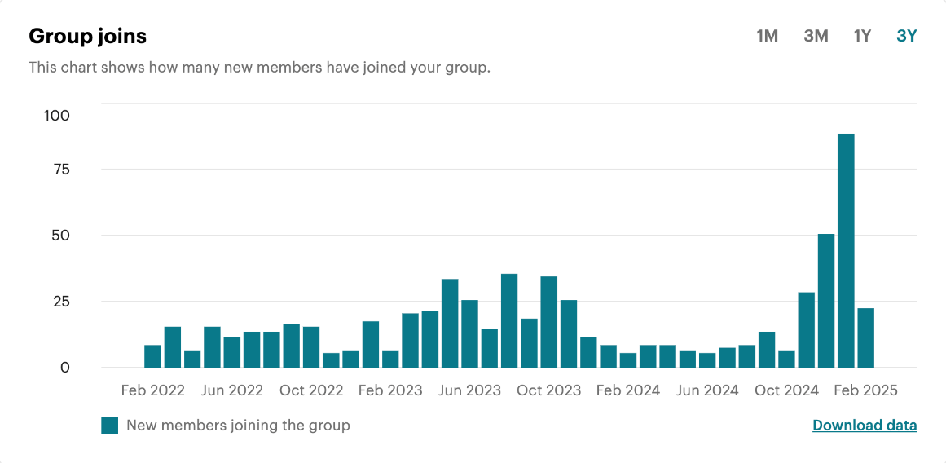
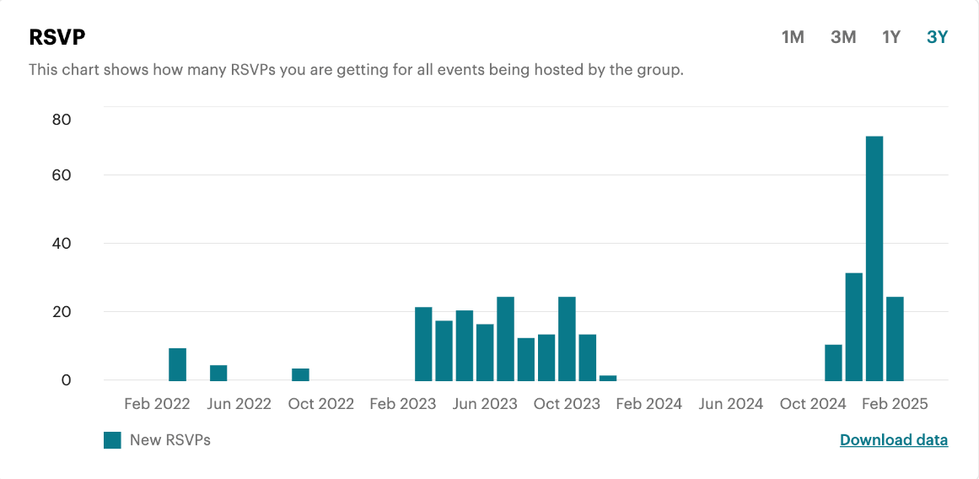
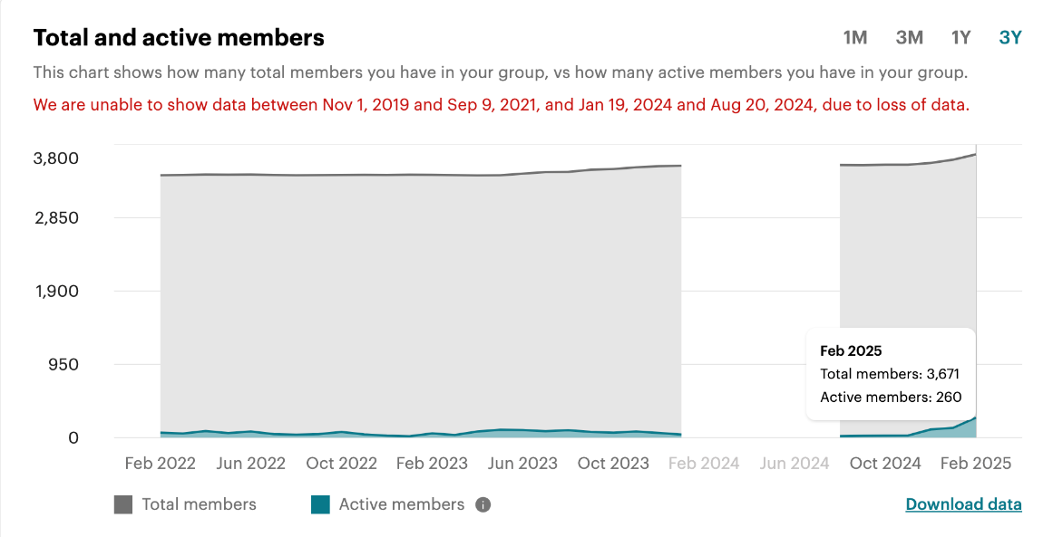

The response has been really positive, with more RSVPs than ever before. I've found using welcoming language and group photos to be highly effective at increasing interest. Meetup allows users to message in the events, or DM the organiser, and users appear to value this when attending events for the first time.

There have been a couple challenges. It can be difficult to respond to on-the-day queries if I am not attending the event personally. Some users assume that being late is acceptable and I've had to explain a few times that this is not the case. I've also heard more general concerns from existing MAD members about preparedness of attendees from Meetup and impact on group sizes.

Looking forwards, the primary question is deciding what content to continue posting on Meetup.

Webmaster (Desi and Rob)

The new committee details are now on the website. On the walk submission for there is a recommendation now – scrambling walks to be limited to 20 people. Social submissions form was amended to request post code for new volunteers.

In January we encountered some unexpected issues with signup forms, such as forms missing the name field, seemingly caused by a Google Scripts change rather than any alteration on our part. We addressed this, but unfortunately various other issues emerged as a result, so we’ve had a bit of back-and-forth on walk forms overall. This should all be stable again now.

Please do report any issues you encounter, even if you’re not absolutely sure about them.

Best regards,
Desi & Rob

Weekends Co Ordinator (Miranda)

1. Weekends Update - February
2. Package Tour Operators Regulations 2018 - is not applicable to MAD Walkers
therefore no action needed
3. Committee meeting dates to be set in advance - Circumstances where dates set
must be changed, and how to pick a replacement date.
4. Personal Note - upcoming absence

1. Weekends Update February
- Two hostel weekends are approved (Glencoe September 2025 and Llanberis New Year 25/26). These will each go live for booking 4 months ahead, so we can forecast to receive deposit income by 3 months ahead. I forecast we will receive the New Year deposit income before the balance payment for Glencoe becomes due. Natalie and I will discuss further when we can.
- A further hostel weekend has been proposed by Lottie (much appreciated as the spring period was looking bare). Planned to be at Helvellyn in April with a budget to be approved shortly; Deposit payment £260 is approved to be paid.
- 4 DIY weekends have been approved, though all are in one four week block between mid-June and mid-July. This presents a risk that each weekend has diluted attendance (note how Jack and Steven are competing with their facebook events already). I tried to get the most recent organiser (Paul Moore) to pick a different date
but he is not keen/available. I’ve blocked out at least one weekend either side of this 4 week series where I won’t approve any more DIYs.
- I am planning to email previous weekend organisers this month to ask if any more hostel weekends are in the works, especially for the spring and autumn, to increase the variety on the calendar.
- I’ve noted from Natalie’s report this month that she needs to understand the financial plan for the “Young Ramblers Weekend” that Sarah Kendall has been coordinating on behalf of Ramblers, which I believe was pencilled-in for early September. We agreed at the December meeting that Sarah would be invited to this February
meeting. Since Natalie and I cannot attend the rescheduled meeting, Sarah’s attendance may be less valuable. If this is still outstanding, please allocate me an action to talk with Sarah and feedback to the group.

2. Tour Operator Guidance
- Over the past year there have been rumours of an uncategorised risk to MAD, or possibly Ramblers, if we run weekends involving “more than 2 activities organised by the group”. This led to a question for this committee whether we should implement guidance for organisers of weekends, that may restrict our future weekend plans. Before any such restrictions are voluntarily placed on us, it is important we clarify the source of any such rule and confirm if any risk exists.
- This rumour appears to be an interpretation of The 2018 Package Travel and Linked Travel Arrangements Regulations (2018 PTRs). This is a statutory instrument which ascribes liability for consumer losses to package tour operators when problems arise with tours organised by such operators.
- Note that if the 2018 PTRs were interpreted to apply to groups such as MAD Walkers, all our weekends could qualify as covered under the rules, as they often involve “two or more travel services” (i.e. not only weekends with “more than two services”), criteria which would potentially be satisfied by MAD providing accommodation, providing meals, and potentially providing walks led by group members which could count as “other tourist activities”, not to mention arranging group transport. In this case, if the regulations were not excluded, MAD would regularly incur significant liability to signed-up members in the event of a problem such as insolvency of a hostel or unavoidable last minute cancellation leading to loss of accommodation costs. Note, we would also be liable for significant fines for not complying with the security and information provisions within the regulations.
- However, the 2018 PTRs specifically exclude “Packages and Linked Travel Arrangements that are organised occasionally and on a not-for-profit basis and for a limited group of travellers, such as a one-off trip arranged by a church for its members. We would consider occasionally to mean no more than a few times a
year.”
This exclusion seemingly applies to MAD, as our weekends are:
- Occasional - not on a regular/predictable rota
- Not-for-profit - all weekends are run at cost
- For a limited group of travellers - restricted to Ramblers members and normally the subset of MAD members

- It is also worth noting that within the regulations there are many other circumstances in which multiple services are provided but the regulations do not apply because they are not deemed to be a package. For example, a hotel can sell a full-board room rate, have a swimming pool, provide a free shuttle bus service from the local station and sell excursion or entertainment tickets once you have checked in without falling within the regulations.
- In conclusion, the suggestion that we should restrict weekends in any way on the basis of this regulation seems unfounded.
- Resolving Action 6 from December Committee meeting, here is the guidance document: The package Travel and Linked Arrangements Regulations 2018 guidance for businesses

3. Committee Meeting Dates
- May we formally agree on the procedure to set Committee meeting dates, so we can schedule our work/social obligations around the meetings. This will maximise attendance through the rest of the year so we function well as a committee for the benefit of the group.
- MAD Committee meetings are held, by convention, on the first Wednesday of the month on a bi-monthly basis, commencing December following each AGM. Keeping to this convention helps many of us to plan ahead. To determine if the quorum of 6 (as set in the constitution) will be met, any committee members who are unable to
attend provide apologies to the secretary as far in advance as possible.
- Unless the secretary has received formal apologies from enough committee roles to demonstrate the quorum cannot be met, the agreed date is honoured.
- At the first meeting in December we agreed that this procedure would continue and agreed that the February meeting would fall as normal on 5th Feb 2025, this is recorded in the December 2024 minutes.
- In the event that it appears (based on receipt of formal apologies) that a quorum cannot be present, a poll may then be appropriate to select an alternative date. If choosing a preferred date on the basis of a poll, especially when several committee roles are shared, we should recognise it is often more valuable to ensure representation from a broad number of areas as opposed to maximising absolute attendance, and the Chair and Treasurer roles typically carry an additional value to the meeting.
- This procedure does not appear to have been followed this month. In this case, the Treasurer and Weekend Coordinator are unable to present and discuss updates relating to group funds. This is a problem as decisions need to be made to ensure we remain solvent, and they should be made in the forum of the whole committee rather than limited to a sub-group. As such we need to recognise that diverging from the procedure for setting dates creates risks for the group beyond merely inconveniencing those of us unable to attend a new date.
- I propose we commit to this procedure and confirm the dates for the remaining meetings this year.

4. Personal Note
- All things being well, I’m expecting to give birth next month, probably in the middle of March. I am shitting myself as you might imagine, probably literally.
- I do not know how I will be once that happens. Several kind people have offered to help out with weekend coordination in this period, namely Martin Ross and Stephen Jones who both have a lot of experience. Generally I may need slightly longer to respond to enquiries for a couple of months, and I may ask Desi and Rob if I can get
an auto-reply on the weekends email inbox to manage expectations.
- I am keen to continue, and grateful to you all for your support. Hopefully John or I will
provide an update to you all when we have news.

Thank you
Miranda

